Course Name | ITD 2343 – Object Oriented Programming with C#
Instructor | Mark L. Pranger
Student Name | Eric Christensen
Due date | Nov 18, 2025
Grade | <grade earned here>
Grading Comments | <instructor comments here>

Week 11 – Programming Lab

Screen Shots needed for Submission:
- Show the code for the buttons in as few screen shots as possible
  - Highlight the button code in the screen shot(s)
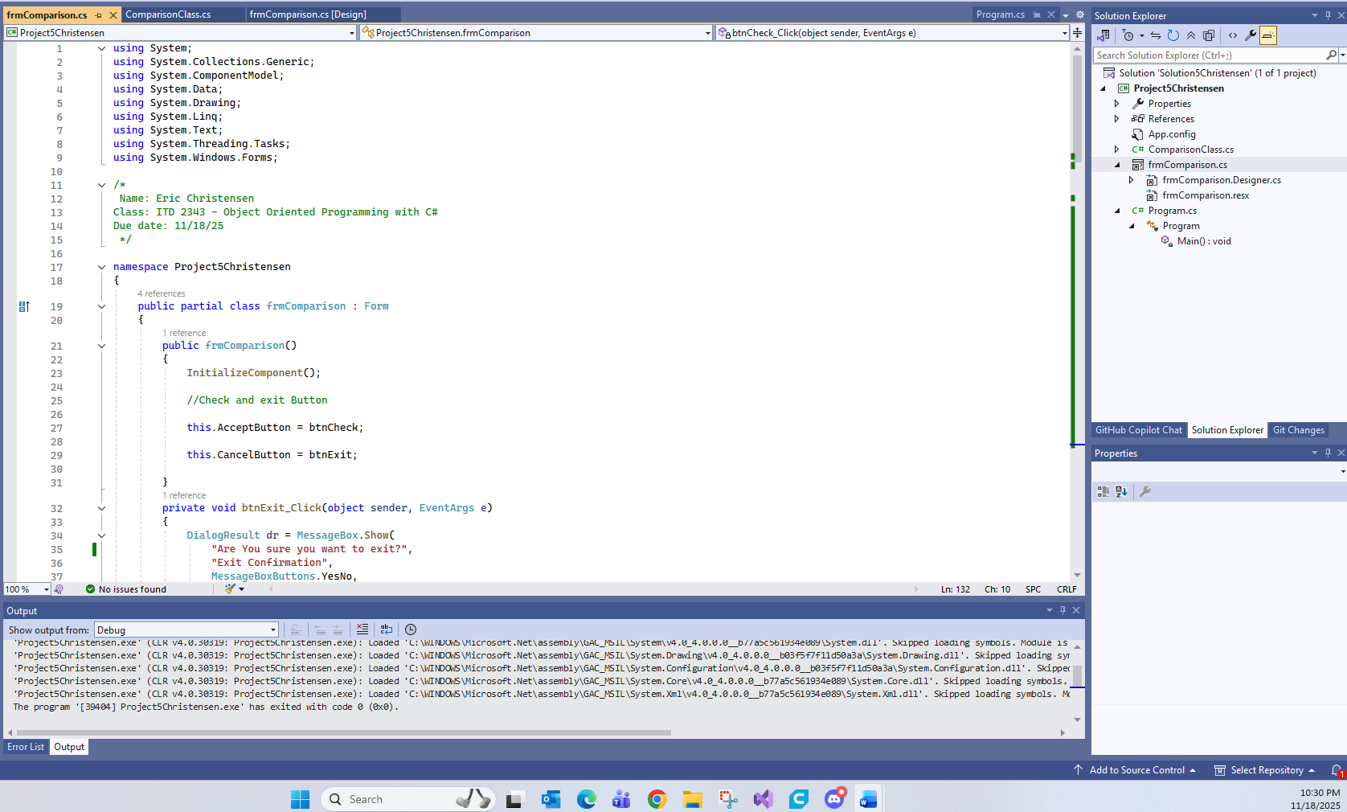
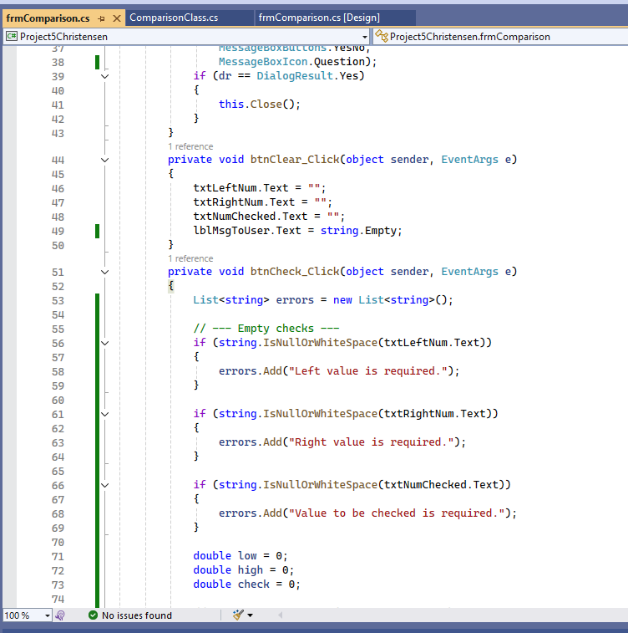
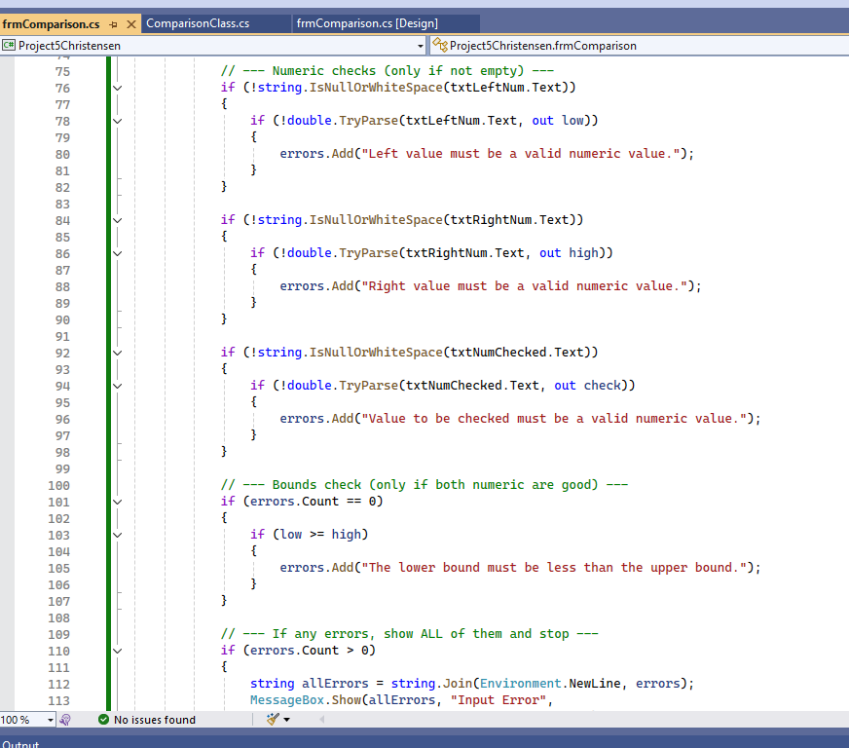
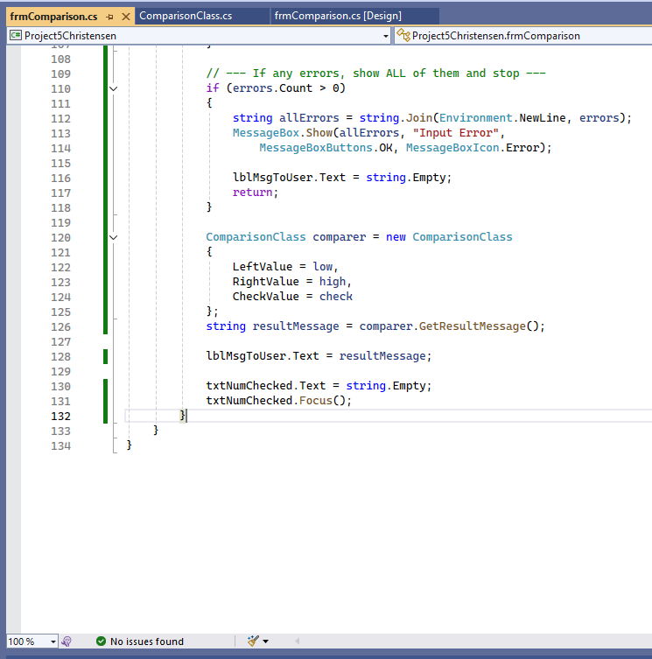

- Show the code for the class also, highlight the Get/Sets and the Math Operations in that code
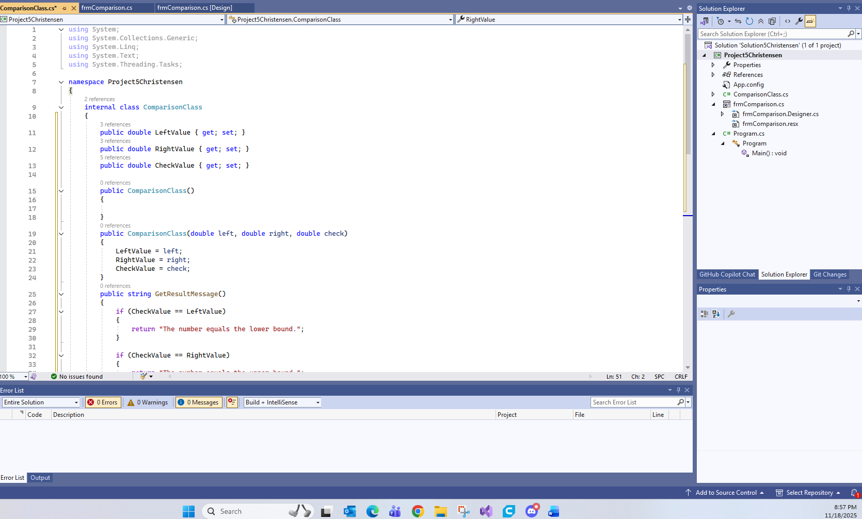

- Run the application in debug mode, screen shot the whole screen showing the form starting up in the center
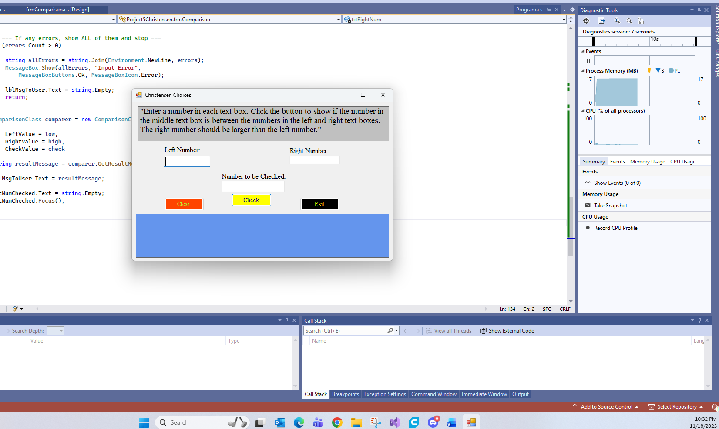

- Screen shot the results of each of the variations (outside the range, equal to the upper or lower bound, within the range) except the Clear and Exit buttons.
#1500
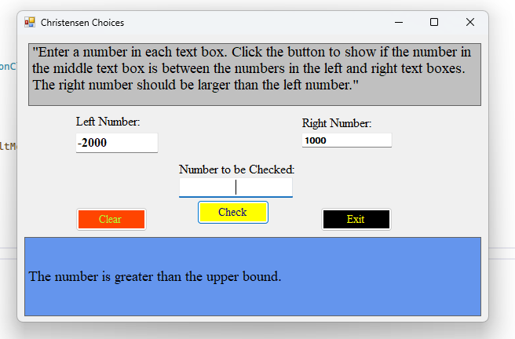
#579
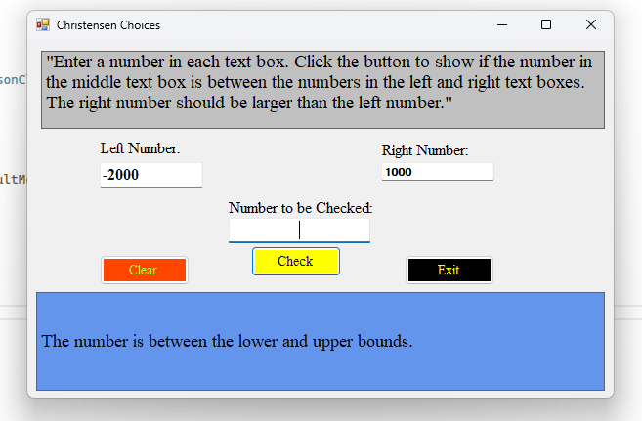
#1000
